Model diagnostics
Used in: No detectable impact of Spat Mussel Collectors on sediment composition in high-energy Wadden Sea environments
Jacob J. Capelle¹, Jildou Schotanus¹, Vincent Escaravage¹
¹Wageningen University & Research -Wageningen Marine Research, Yerseke, The Netherlands

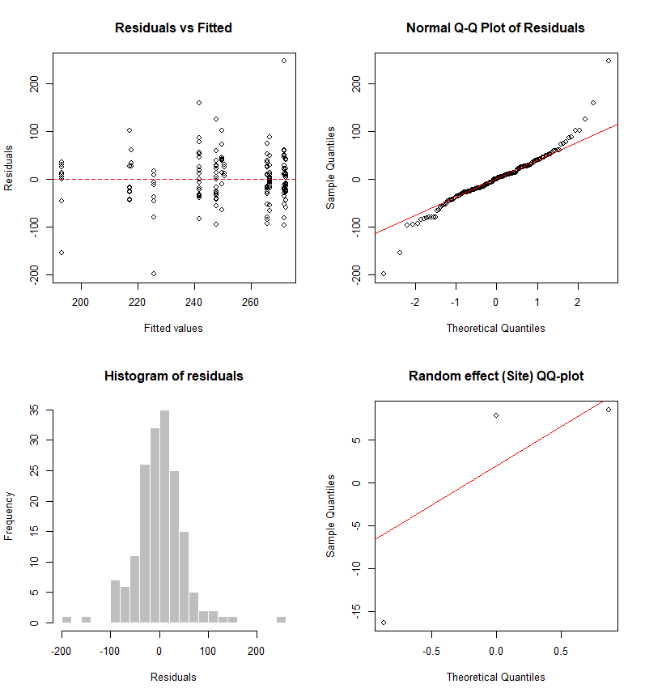
Figure 1 Diagnostic plots for sediment size: Med-mu. Model: Y_ijk = β₀ + β₁Position_i + β₂Time_j + β₃(Position×Time)ij + b_k + ε_ijk, where Y_ijk is the response for position i (Inside/Outside), time j (T0/T2), and site k (MZ/VZ/GvS); β₀-β₃ are fixed effect coefficients; b_k ~ N(0, σ²_site) is the random site effect; and ε_ijk ~ N(0, σ²) is the residual error.

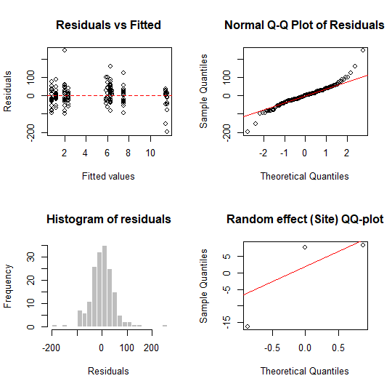
Figure 1 Diagnostic plots for organic carbon: CORG. Model: Y_ijk = β₀ + β₁Position_i + β₂Time_j + β₃(Position×Time)ij + b_k + ε_ijk, where Y_ijk is the response for position i (Inside/Outside), time j (T0/T2), and site k (MZ/VZ/GvS); β₀-β₃ are fixed effect coefficients; b_k ~ N(0, σ²_site) is the random site effect; and ε_ijk ~ N(0, σ²) is the residual error.
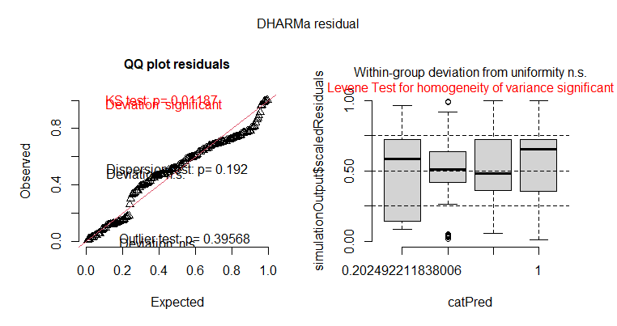
Figure 3 Diagnostic plots for Silt Content. Model: generalized linear mixed model with beta distribution and logit link: logit(μ_ijk) = η_ijk = β₀ + β₁Position_i + β₂Time_j + β₃(Position×Time)ij + b_k, where μ_ijk is the expected proportion for observation ijk, and the variance is: Var(Y_ijk) = μ_ijk(1-μ_ijk) / (1 + φ_ij), where φ_ij is the precision parameter, modeled as: log(φ_ij) = γ₀ + γ₁Position_i + γ₂Time_j + γ₃(Position×Time)ij

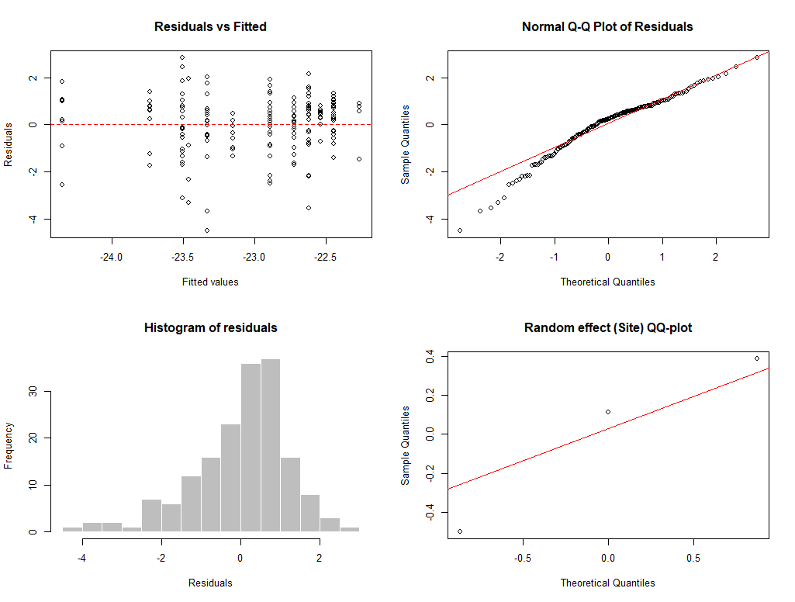
Figure 4 Diagnostic plots for δ¹³C Model: Y_ijk = β₀ + β₁Position_i + β₂Time_j + β₃(Position×Time)ij + b_k + ε_ijk, where Y_ijk is the response for position i (Inside/Outside), time j (T0/T2), and site k (MZ/VZ/GvS); β₀-β₃ are fixed effect coefficients; b_k ~ N(0, σ²_site) is the random site effect; and ε_ijk ~ N(0, σ²) is the residual error.

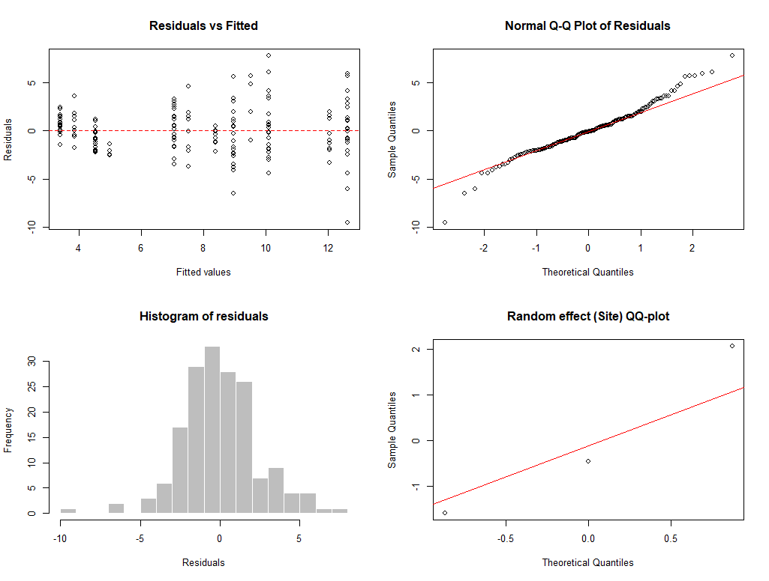
Figure 5 Diagnostic plots for δ¹⁵N Model: Y_ijk = β₀ + β₁Position_i + β₂Time_j + β₃(Position×Time)ij + b_k + ε_ijk, where Y_ijk is the response for position i (Inside/Outside), time j (T0/T2), and site k (MZ/VZ/GvS); β₀-β₃ are fixed effect coefficients; b_k ~ N(0, σ²_site) is the random site effect; and ε_ijk ~ N(0, σ²) is the residual error.

